**DAILY ONLINE ACTIVITIES SUMMARY**

|  |  |  |  |  |  |  |  |  |
| --- | --- | --- | --- | --- | --- | --- | --- | --- |
| **Date:** | **27/05/2020** | | | | | **Name:** | **Kavya R Shetty** | |
| **Sem & Sec** | **6th /A** | | | | | **USN:** | **4AL17CS089** | |
| **Online Test Summary** | | | | | | | | |
| **Subject** | | **SSCD IA Test - 2** | | | | | | |
| **Max. Marks** | | **30** | | **Score** | | | **20** | |
| **Certification Course Summary** | | | | | | | | |
| **Course** | **INTRODUCTION TO ETHICAL HACKING** | | | | | | | |
| **Certificate Provider** | | | **GREATLEARNING** | | **Duration** | | | **6HRS** |
| **Coding Challenges** | | | | | | | | |
| **Problem Statement:**   1. Python Program to print all the numbers not divisible either by 3 or 2 lieing between 1 &50 2. Python Program to print given digit is palindrome or not | | | | | | | | |
| **Status: Completed** | | | | | | | | |
| **Uploaded the report in GitHub** | | | | | **Yes** | | | |
| **If yes Repository name** | | | | | **https://github.com/kavyashetty-765/DAILY-STATUS** | | | |
| **Uploaded the report in slack** | | | | | **Yes** | | | |

**Online Test Details**

SSCD TEST-2 Details:

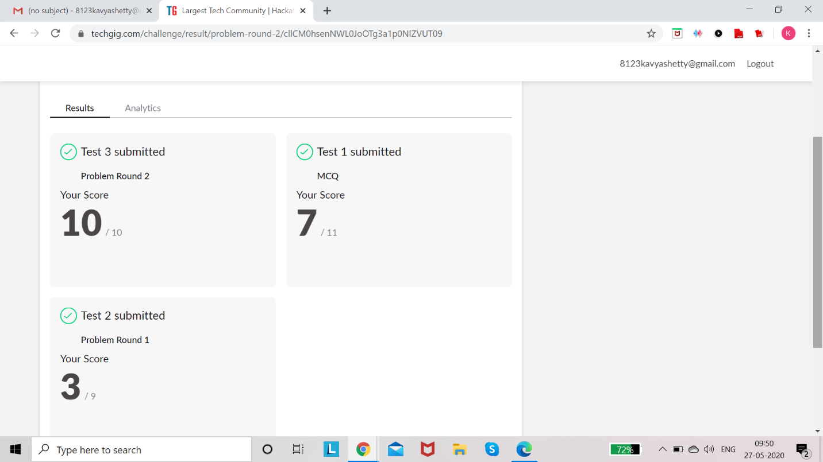

**Online Certification Details**

**Lesson** 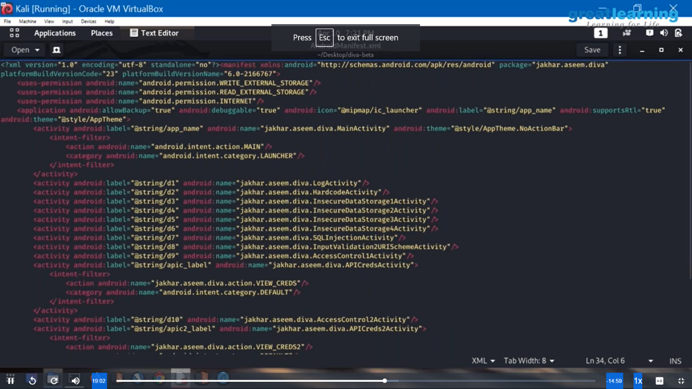

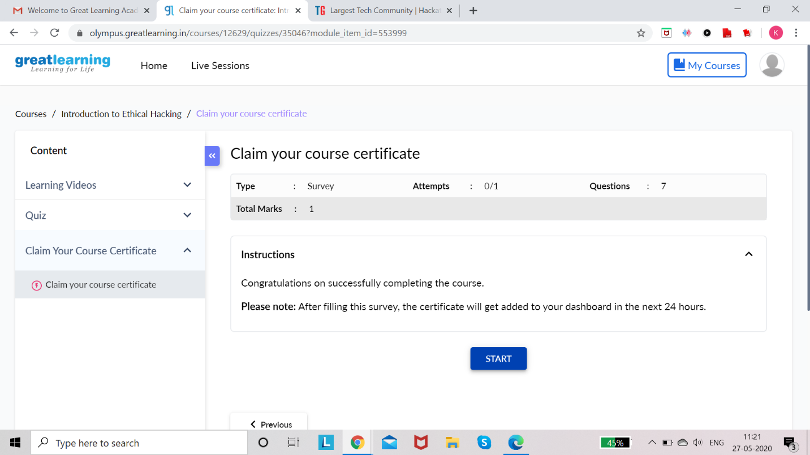

**Coding Challenge Details**

1. Python Program to print all the numbers not divisible either by 3 or 2 lieing between 1 &50

2. Python Program to print given digit is palindrome or not.

